**GYMNÁZIUM, VLAŠIM, TYLOVA, 271**



|  |  |
| --- | --- |
| **Autor** | **Mgr. Šárka Hlaváčková** |
| **Číslo materiálu** | **1_3_ANJ_15** |
| **Datum vytvoření** | **13. 10. 2012** |
| **Druh učebního materiálu** | **Pracovní list** |
| **Ročník** | **4. ročník** |
| **Anotace** | **Pracovní list s konverzačními otázkami a popisem obrázku** |
| **Klíčová slova** | **Shopping, shops, bargain, department store** |
| **Vzdělávací oblast** | **Jazyk a jazyková komunikace – anglický jazyk** |
| **Očekávaný výstup** | **Žák je schopen konverzovat na téma Shopping.** |
| **Zdroje a citace** | **www.wikipedia.cz** |



**Konverzační téma - Shopping**

**1. Answer the following questions.**

1. How often do you go shopping?
2. What kind of things do you usually go shopping for?
3. Do you like shopping? Why / why not?
4. What's your favourite shop?
5. Do you prefer large supermarkets or small local shops? Why?
6. What time of day do you think is best to do your shopping? Why?
7. What do you hate most about shopping?
8. Do you often buy yourself presents? What was the last present you bought for yourself?
9. Who are 'shopaholics'? Are you a shopaholic?
10. How do you prefer to pay, in cash or by card? What are the positives and negatives of both?
11. How and where can you get a credit card?
12. What do the following people do: cashier, customer, shop assistant / shopkeeper?
13. When are there usually discounts? Are they very popular in your country?
14. How do shops try to attract customers?
15. What are the positives and negatives of internet shopping?
16. Have you ever bought anything on the Internet?
17. What's your experience with ordering goods from a catalogue? What are the positives and negatives?
18. What is 'window shopping'? Do you like window-shopping?
19. How do shop windows usually change during the year?
20. Do you usually buy brand name products? Why?
21. What can you do when you have bought something faulty? How can you complain?
22. Have you ever made a complaint about something you bought?
23. What is 'shoplifting' and do you think it is a big problem these days?
24. How can shops prevent shoplifting?
25. Do you think that people in the future will do their shopping in the same way we do now?
26. If you want to buy something expensive (e.g. a new computer), can you do it even though you don't have enough money? How?
27. Are there all the important shops in your town/village? Are you happy with the shops in your town?

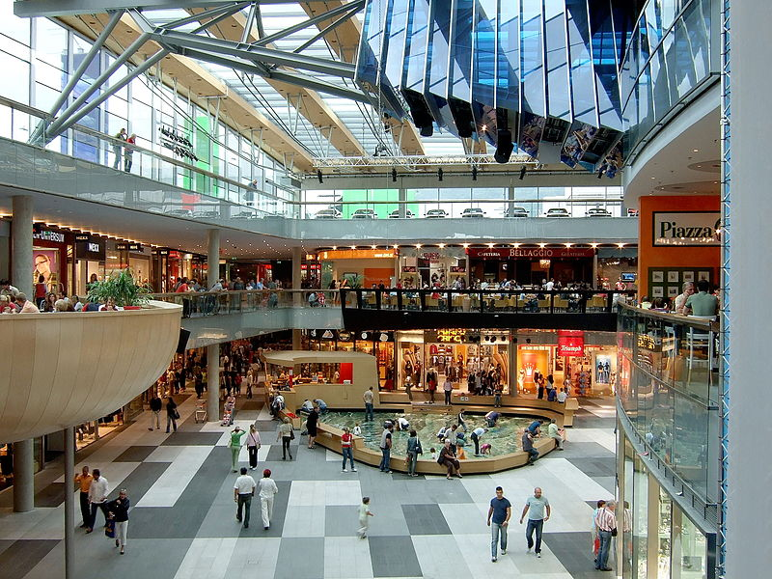**2. Give detailed description of the following picture.**

<http://upload.wikimedia.org/wikipedia/commons/4/45/Villach_Atrio_Shopping_Center_11082007_11.jpg>