**GYMNÁZIUM, VLAŠIM, TYLOVA, 271**



|  |  |
| --- | --- |
| **Autor** | **Mgr. Šárka Hlaváčková** |
| **Číslo materiálu** | **1_3_ANJ_14** |
| **Datum vytvoření** | **11. 10. 2012** |
| **Druh učebního materiálu** | **Pracovní list** |
| **Ročník** | **4. ročník** |
| **Anotace** | **Pracovní list s konverzačními otázkami a popisem obrázků** |
| **Klíčová slova** | **Ecology, environment, nature** |
| **Vzdělávací oblast** | **Jazyk a jazyková komunikace – anglický jazyk** |
| **Očekávaný výstup** | **Žák je schopen konverzovat na téma Ecology, environment** |
| **Zdroje a citace** | **www.wikipedia.cz** |



**Konverzační téma – Ecology, Environment**

**1. Answer the following questions.**

1. Why is ecology so important?
2. Are there any environmental problems in your region? What are they? How are they caused?
3. Why should we care about our environment?
4. Do you know about any global environmental problems? Which of them do you think are most serious and why?
5. What is Greenhouse effect?
6. What is the ozone layer and what is its function?
7. What is 'global warming'? Why is it a negative thing?
8. What possible environmental problems can the future bring?
9. Why is it dangerous to cut down the rainforests?
10. What types of 'extreme weather' do you know? Is it connected with environmental problems?
11. Have you seen any catastrophic movies connected with environmental? Which one?
12. What can we do to help our environment?
13. Do you agree that 'an individual cannot do anything to stop environmental problems'?
14. What is recycling?
15. What cen be recycled?
16. What should people save to help the nature?
17. Do you know any renewable sources of energy?
18. What do you think about nuclear energy?
19. Do you know any endangered species of animals or plants?
20. Why should we protect them?
21. Do you know any eco-friendly organizations?
22. What do they focus on?

**2. Look at the pictures below and describe them.**

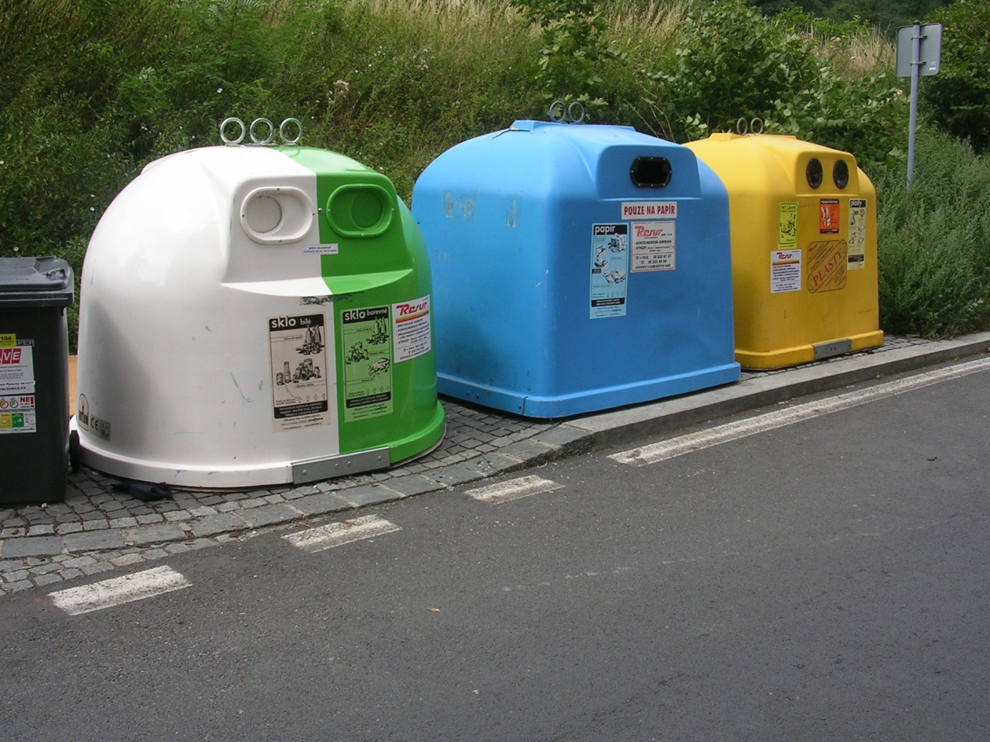[1]

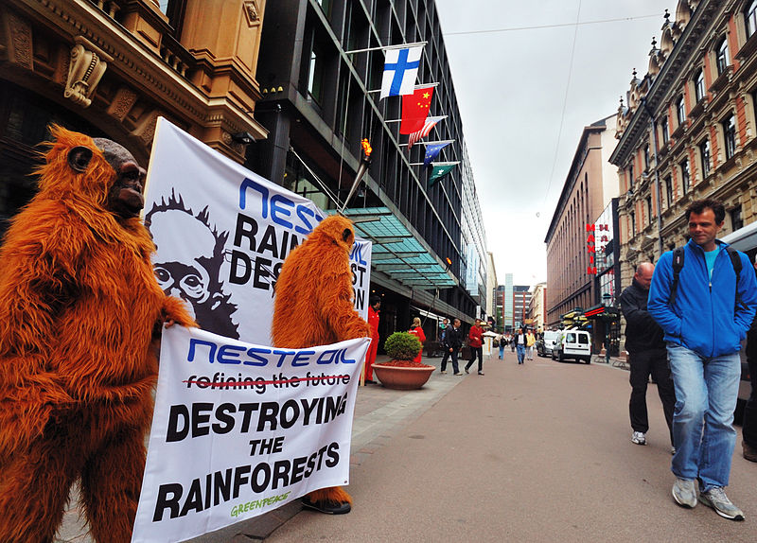[2]

1. http://upload.wikimedia.org/wikipedia/commons/thumb/a/ab/N%C3%A1b%C5%99e%C5%BE%C3%AD_J._Palacha_-_Foersterova%2C_kontejnery.jpg/800px-N%C3%A1b%C5%99e%C5%BE%C3%AD_J._Palacha_-_Foersterova%2C_kontejnery.jpg
2. http://upload.wikimedia.org/wikipedia/commons/thumb/c/ce/Greenpeace_biodiesel_demonstration.jpg/800px-Greenpeace_biodiesel_demonstration.jpg