**GYMNÁZIUM, VLAŠIM, TYLOVA, 271**



|  |  |
| --- | --- |
| **Autor** | **Mgr. Šárka Hlaváčková** |
| **Číslo materiálu** | **1_3_ANJ_13** |
| **Datum vytvoření** | **19. 9. 2012** |
| **Druh učebního materiálu** | **Pracovní list** |
| **Ročník** | **4. ročník** |
| **Anotace** | **Pracovní list s konverzačními otázkami a popisem obrázků** |
| **Klíčová slova** | **Food, breakfast, lunch, dinner, meal** |
| **Vzdělávací oblast** | **Jazyk a jazyková komunikace – anglický jazyk** |
| **Očekávaný výstup** | **Žák je schopen konverzovat na téma Food.** |
| **Zdroje a citace** | **www.wikipedia.cz** |



**Konverzační téma - Food**

1. What is your favorite food?
2. What is your favorite meal of the day?
3. What time do you usually have your meals?
4. Do you often go to restaurants?
5. When did you last eat out? What did you have?
6. Do you eat in a school canteen?
7. Would you like to work as a cook / waiter? Why? Why not?
8. What's your favorite drink (alcoholic/non-alkoholic)?
9. How would you describe typical Czech / British / American etc. Cosine.
10. Can you cook? What do you like cooking?
11. Should cokery be a school subject?
12. Do you think you eat healthy food?
13. Do you like exotic or unusual food?
14. Who does the cooking in your house?
15. What is the most exotic food you have ever eaten?
16. Is there anything you have never eaten and would like to try it?
17. What is the worst thing you have ever eaten?
18. Do you watch TV programmes about cooking or read cook books?
19. Do you agree that 'men are better cooks than women'?
20. Who is a vegetarian?
21. Which restaurant would you recommend to a foreigner who would like to have a delicious meal?
22. Is food expensive in your country?
23. Why do some people decide to go on a diet?
24. What should you eat/do if you want to lose weight and look slim?
25. Is it possible to be addicted to any kind of food or drink?

**2. Choose one of the pictures on the following page and describe it.**

**3. Compare these two pictures.**

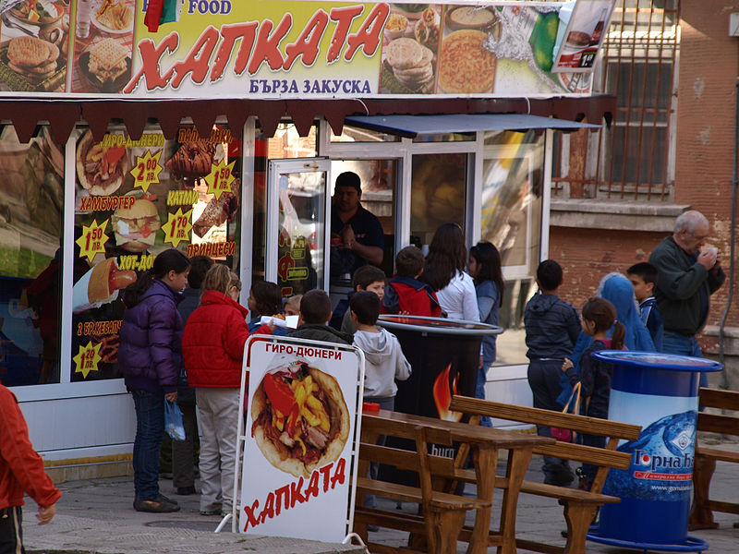[1]

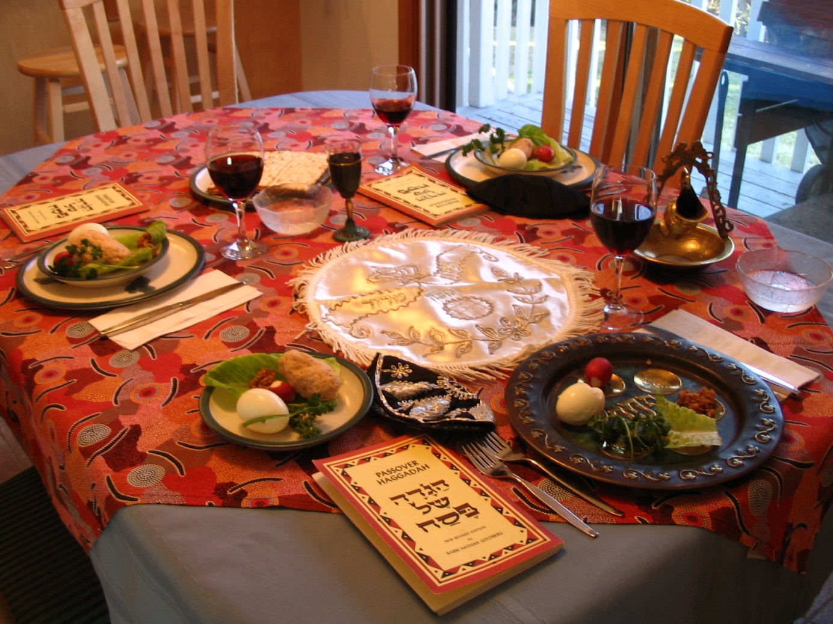[2]

1. http://upload.wikimedia.org/wikipedia/commons/thumb/f/fe/Fast-food-in-Yambol.jpg/800px-Fast-food-in-Yambol.jpg
2. http://upload.wikimedia.org/wikipedia/commons/thumb/b/b7/A_Seder_table_setting.jpg/800px-A_Seder_table_setting.jpg